

Advocacy Within Schools


Service based within Some of
Dumfries & Galloway Schools
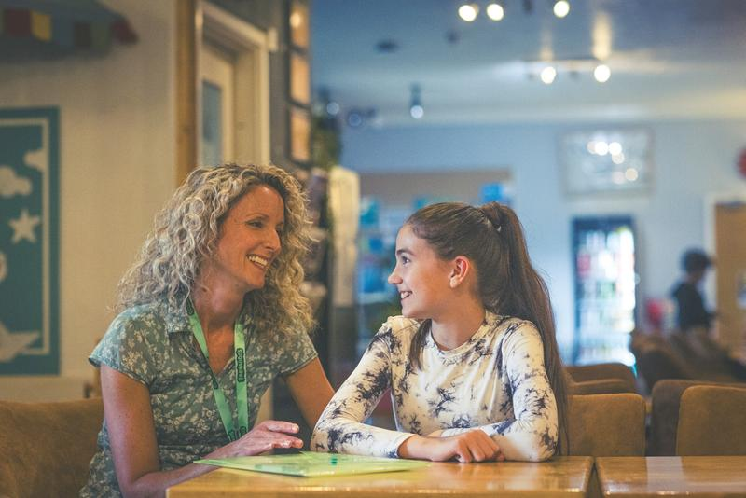
Advocacy Within Schools (AWS) is an independent service that offers a drop-in service available to Children & Young People (C/YP) in both Primary & Secondary Schools

Our Advocacy Worker, Marie Wight, offers a space for C/YP to talk about their worries or issues and further supports them through offering suggestions to help them move forward with these.

Support through Advocacy can be offered in many ways, some of this can be through listening, passing on views, signposting services & information, gaining access to useful resources & also from carrying out activities to help C/YP reach a positive outcome.

Support can be offered within many areas of their wellbeing. Some areas may include the following: -


School Issues
Subject / Exam Stress
Pressures


Bullying
Friendship Conflicts
Relationship Issues

Home Issues
Bereavement
Poverty
Isolation

Socialising
Access to Clubs
Friendship Building
There are many more areas that can be supported through Advocacy Within Schools.
The aim of this service is to provide support at the beginning of any worries and issues before they become unmanageable.

Barnardos proudly encourages and promote Children’s Rights while offering support along the way.

C/YP can be referred into the service by any Professional or Parent / Carer who feels a C/YP requires support (12 years and over can also self-refer) To Refer a pupil into the service please complete the following Referral Form within the link provided below: -
Hear 4u Advocacy Service Dumfries Galloway referral form | Barnardo's
If you wish to contact our Advocacy Worker direct to enquire or to discuss anything, please use the contact details below
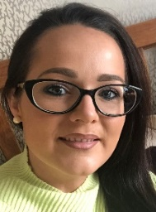

Marie Wight
Independent Advocacy Worker
Mental Health & Wellbeing
Mobile: 07564055829
Office: 01387 264733
Email: marie.wight@barnardos.org.uk

(Note: Advocacy Within Schools does not offer Counselling Sessions)



